**B2-SET A**

**PART A**

1. Predict the output of the following

from pyDatalog import pyDatalog

def twice(a):

return a+a

pyDatalog.create_terms('twice')

print((X==1) & (Y==twice(X)))

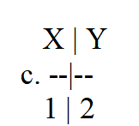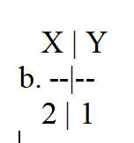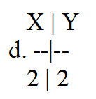

X | Y

a. --|--

1 | 1

1. Predict the output of the following

from pyDatalog import pyDatalog

pyDatalog.create_terms('X, Y')

print((Y==1) & (Y==X+1))

1. **[]**
2. 1 2
3. 2 1
4. [1 2]
5. A dependent pair may have a ----------- of which the type depends on the first value
6. Third value
7. **Second value**
8. Zeroth value
9. nth value
10. A push down automaton employs ________ data structure.

a) Queue

**b) Stack**

c) Hash Table

d) Linked List

1. STREAM and DGRAM is purely meant for

a. UDP and TCP

b**. TCP and UDP**

c. FTP and TCP

d. UDP and HTTP

1. If the protocols is UDP, which method is used to receive messages at end point?

a. sock_object.recv()

b. recvfrom()

**c. sock_object.recvfrom()**

d. recvinfo()

1. Which programming paradigms can manipulate its own formulas and program components?

a. Functional programming paradigms

b. Imperative programming paradigms

**c. Symbolic programming paradigms**

d. Declarative programming paradigms

8. The symbolic paradigm function which aids in finding the roots of equation is

**a. sym.solve()**

b. ym,solveset()

c. sym.factors()

d. sym.diff()

1. Predict the output of the follwoing

from sympy import *

rslt = oo + 10000

print("value of rslt is :" + str(rslt))

a. value of rslt is :1000

b. value of rslt is :1001

c. value of rslt is :NULL

**d. value of rslt is :oo**

1. The set of all strings over the alphabet S = {a, b} (including e) is denoted by
2. **(a + b)\***
3. (a + b)+
4. a+b+
5. a*b*